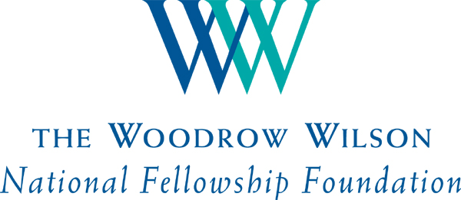 | FACT SHEET:  The 2014 Woodrow Wilson New Jersey Teaching Fellows

About the Fellowships
- The goals of the Woodrow Wilson Teaching Fellowships are to:

  - attract the very best candidates to teaching;
  - put strong teachers into high-need schools;
  - cut teacher attrition and retain top teachers; and
  - transform university-based teacher education.

- The Fellowships recruit teachers—both recent college graduates and career changers—with strong backgrounds in the STEM fields (science, technology, engineering, and mathematics).
- In New Jersey the program is supported by a consortium of funders, coordinated by the Geraldine R. Dodge Foundation, with initial funding of $10.6 million.
- Each Woodrow Wilson Teaching Fellow receives a $30,000 Fellowship to complete a specially designed,
cutting-edge master’s degree program, as preparation to teach in high-need urban or rural secondary schools.
- Fellows commit to teach for three years, with ongoing mentoring.
- Universities agree to redesign their teacher education programs.
- New Jersey launched its Woodrow Wilson Teaching Fellowship in 2012, with partner campuses preparing their Fellowship programs in the intervening months. The 2014 class of Fellows is the first class (or cohort) of Fellows to be named in New Jersey.

About the 2014 Woodrow Wilson New Jersey Teaching Fellows
- In 2014, the Foundation has named 50 Woodrow Wilson New Jersey Teaching Fellows. They will attend the College of New Jersey; Montclair State University; Rowan University; Rutgers University—Camden; and William Paterson University.
- Of these new WW New Jersey Teaching Fellows:
- 100% majored in a STEM discipline.
  - 76% (37 Fellows) majored in the sciences, 8% in engineering and technology, and 16% in mathematics.
- 30% (16 Fellows) have done advanced degree work.
  - The Fellows have 14 master’s degrees among them, including one M.P.H. and one M.B.A.
  - Five Fellows also have Ph.D.s.
- Most Fellows are Dean’s List/honors graduates, with memberships in various academic honoraries.
- Just over two-thirds of the Fellows—68%—are new or recent grads. The rest are seasoned career-changers.
  - 22 Fellows (44%) graduated from their undergraduate institution this year.
  - Another 12 (24%) have graduated in the last five years, including four who went on to master’s programs.
  - The remaining 15 Fellows (30%) completed the undergraduate degree more than five years ago; six have more than a decade’s experience in the workforce, including such agencies and companies as the New York City Department of Health, the U.S. Patent and Trademark Office, Prudential, Merck, and GlaxoSmithKline.
- Half are male—noteworthy in a profession where as many as three-quarters of practitioners are female—and 33% are teacher candidates of color (versus 16% in the overall teaching force).
- The Fellowship is creating some in-state opportunities for talented New Jerseyans; fully 90% of the Fellows are New Jersey residents. The five out-of-staters come from NY, PA, OH, IL and TX.
- Fellows are graduates of outstanding local, regional, and state institutions—including all five partner campuses, Seton Hall and multiple Rutgers University campuses—as well as such nationally noted colleges and universities as Yale University, the Johns Hopkins University, New York University, the University of Texas, the University of California at Berkeley, and others.
- Fellows remain deeply committed to community service. Most have volunteered with such organizations as Special Olympics, Habitat for Humanity, the American Cancer Society, and others. Many are also active in their faith communities and with youth arts and sports organizations.

